

**Jobs you can do - the Café**

Topping a pizza

Most pizzas have a tomato sauce spread on the base and some cheese sprinkled on top. Here are some other toppings a pizza might have:

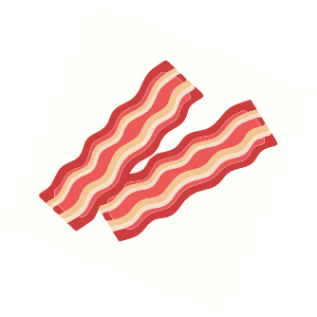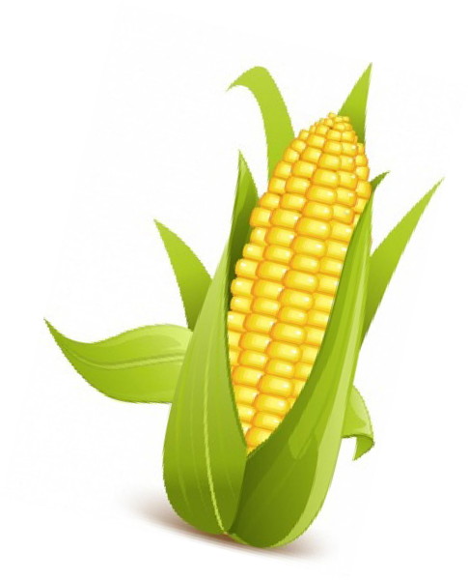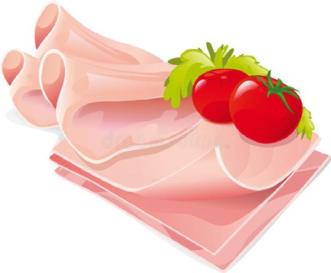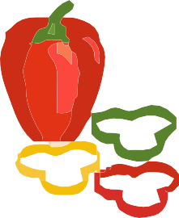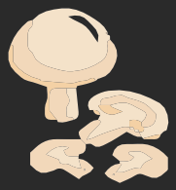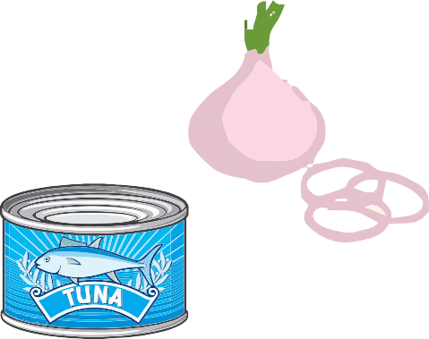

Tuna

Mushrooms

Onion

Olives

Bacon

Peppers

Ham

Sweetcorn

Can you think of any others? If so, write or draw them below:

Now you can design your own pizza. Write or draw up to 5 toppings that you would like on the pizza below:

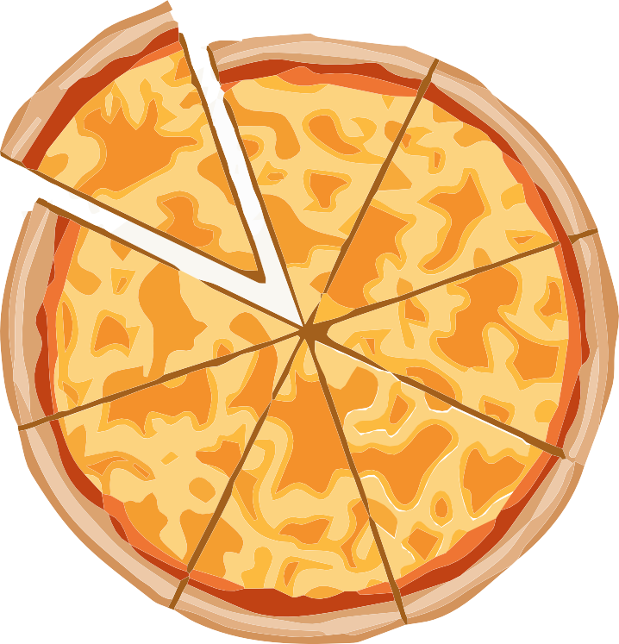

If you work in a café you will top pizzas for other people.

Some people do not want some foods. Here are some examples: A vegetarian will not want meat.

A vegan will not want meat or cheese.

Can you design a pizza for a vegetarian or a vegan?

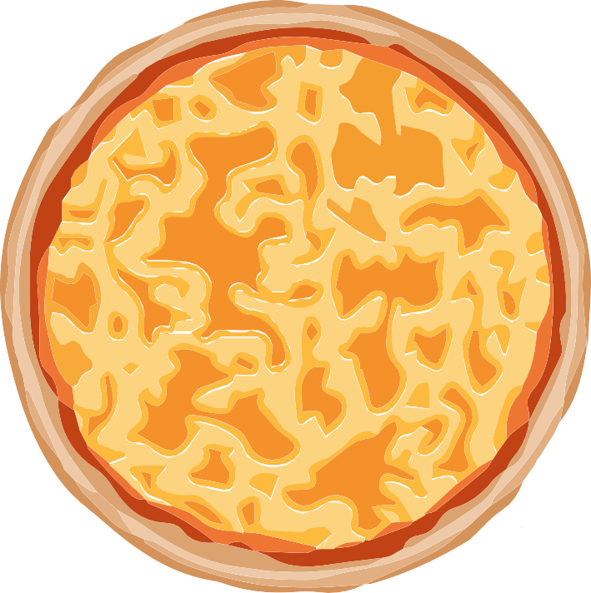

Some people cannot eat some foods because they make them unwell.

Do you know anyone who cannot eat some foods? You could talk to them about this.

Content and design by

Somerset Education Business Partnership

