

**Jobs you can do - the Holiday Cottage**

Could you get the Holiday Cottage ready for its next visitors? Here are some rooms that need preparing:

* The kitchen
* The bathroom
* The bedroom
* The lounge

And here are some jobs that need doing:

* Dusting
* Wiping surfaces
* Emptying bins
* Washing floors
* Making beds

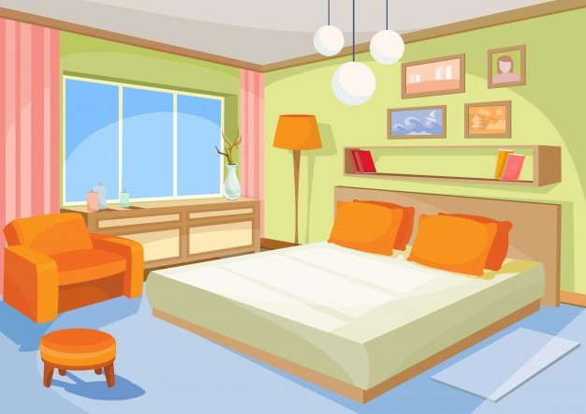

Now pick 3 rooms and decide what jobs need doing and the tools you need to do them.

**Room 1**

|  |  |
| --- | --- |
| The room I will clean is: |  |
| The jobs I will do are: |  |
| The tools I need are: |  |

**Room 2**

|  |  |
| --- | --- |
| The room I will clean is: |  |
| The jobs I will do are: |  |
| The tools I need are: |  |

**Room 3**

|  |  |
| --- | --- |
| The room I will clean is: |  |
| The jobs I will do are: |  |
| The tools I need are: |  |



Content and design by

Somerset Education Business Partnership