• •

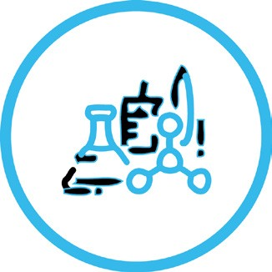

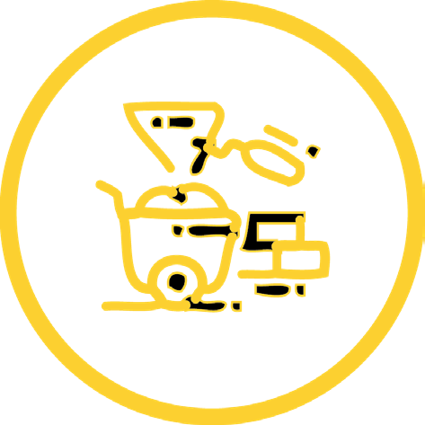SOMERSET

E

• •

•

•

••

•

FIND A JOB YOU LOV CHALLENGE 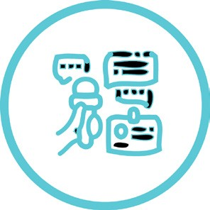

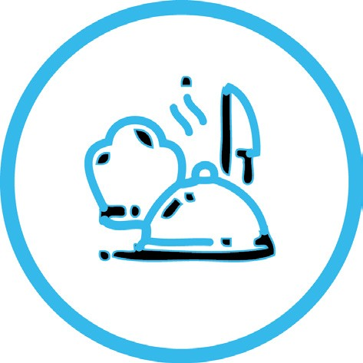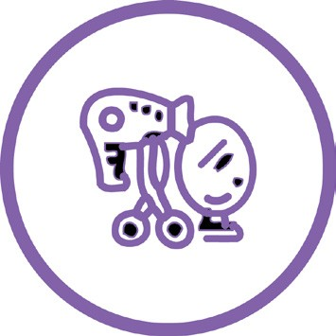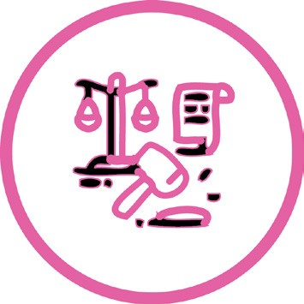

# INTRODUCTION

**Welcome to My Futures Careers Challenge Day!**

### You can complete this work sheet on screen. Type your answers to each task in the boxes provided.

Your work does not automatically save. Be sure to save your work each time you complete a new task or section.

All links in the document are live, so you can navigate away to watch videos or look at other websites.

When you come to the end of the My Futures Careers Challenge Day, make sure you save a copy of your work for your records and forward a copy to your teacher using the platform instructed by your teacher e.g. school homework platform / email.

We hope you enjoy learning about careers that are interested in and discovering more about the world of work.

If you would like to watch interviews with employees from a wide range of Somerset businesses, from industries such as Environmental Science, Media and Creative, Engineering, manufacturing & robotics, Education – and lots more - you can go to the [Somerset Education Business Partnership Youtube channel](https://www.youtube.com/channel/UCwTkNIz0W7sTgn7mJcb2lOQ) to find out more.

Don’t forget to share your thoughts and ideas about My Futures Careers Challenge Day with us on social media using #myfutures

**#myfutures**



# FIND A JOB YOU LOVE CHALLENGE

Name:

Tutor Group:

This challenge is all about getting to know yourself better so that you can make the decisions

that will help you find a job you love.

Aims

At the end of this project you will have explored the following -

* how you’d like your life to be in ten years time
* what style of learning suits you best
* what your core values are

There are three sections. For each section, watch the video where you will get to hear from people who love their jobs, then complete the worksheet.

The most important thing to remember for this challenge is that there are no right or wrong answers. This is about you getting to know yourself better and finding the things that you enjoy. Good luck!

ME IN TEN YEARS TIME

[Click here to watch a video of people talking about their careers and what they enjoy about their job.](https://youtu.be/qqxebdiPMGE)

[Now take a moment to close your eyes and imagine a really great version of your life, in ten years time. Fill in each of the boxes to describe what you imagined.](https://youtu.be/qqxebdiPMGE)

I spend my time doing...

I spend my time with...

I would like people to describe me as...

What I would like to contribute to the world...

I have...

Draw your life...

## TYPES OF LEARNING

### [Click here to watch a video where people talk about the types of learning they have enjoyed throughout their journey.](https://youtu.be/pP0xVDu4zbM)

[There are lots of ways to learn and grow through your career. There is no better or worse way, the most important thing is to understand yourself and the way that you work. This way you will be able to find the environments where you can thrive.](https://youtu.be/pP0xVDu4zbM)

### [Learning Routes](https://youtu.be/pP0xVDu4zbM)

[The different learning routes will provide you with different types of knowledge and will be taught in different ways.](https://youtu.be/pP0xVDu4zbM)

### [Post-16](https://youtu.be/pP0xVDu4zbM)

[Once you have completed GCSEs you have several options to continue learning. Here are](https://youtu.be/pP0xVDu4zbM)

[some of the main ones:](https://youtu.be/pP0xVDu4zbM)

#### [A-levels & vocational certificates and diplomas.](https://youtu.be/pP0xVDu4zbM)

[These are taught in a classroom environment. Vocational certificates and diplomas usually include an element of workplace experience.](https://youtu.be/pP0xVDu4zbM)

#### [T-Levels](https://youtu.be/pP0xVDu4zbM)

[These qualifications are designed to prepare you for a specific industry. They are primarily taught in the classroom, but have a significant workplace element.](https://youtu.be/pP0xVDu4zbM)

#### [Apprenticeships](https://youtu.be/pP0xVDu4zbM)

[These are jobs with learning built in. You will spend 80% of your time learning on the job and 20% in off-the job training.](https://youtu.be/pP0xVDu4zbM)

### [Post-18](https://youtu.be/pP0xVDu4zbM)

[You will have more choices post-18. These include:](https://youtu.be/pP0xVDu4zbM)

* [entering higher education – there are many subjects and teaching styles to choose from,](https://youtu.be/pP0xVDu4zbM)

[including purely academic courses and highly practical applied courses](https://youtu.be/pP0xVDu4zbM)

* [starting a higher or degree level apprenticeship – where you will spend most of your time learning on the job with some dedicated off-the job learning.](https://youtu.be/pP0xVDu4zbM)

[You may also begin employment at this point, whilst some people volunteer or take work placements to learn about particular industries.](https://youtu.be/pP0xVDu4zbM)

[These questions will help you think about your style of learning. If you pay attention to the things that you do well at and enjoy over the next few years, your self-awareness will grow and it will be easier to make the decisions when you need to.](https://youtu.be/pP0xVDu4zbM)

**Write an example of when you have enjoyed working on something.**

It can be a hobby, an activity or a school project.

**What type of learning do I enjoy most?**

Highlight the type of learning suits you best.

* Visual Learner - I prefer to see information and to visualise the relationships between ideas
* Auditory Learner - I prefer to hear information rather than reading it or seeing it displayed visually
* Reading/ Writing Learner - I prefer to interact with text when I am learning
* Kinesthetic Learners - I prefer to be hands-on, I learn best by doing

**When learning a new skill or hobby how would I most like to go about it?**

Highlight two types of work that describe what you enjoy the most.

* Being shown
* Following written or recorded instructions

>Theoretical reading

>Working it out myself

**How do I think I would most like to learn?**

Look back at all your answers and highlight the way in which you think you would most like to be learning.

* Academic course
* Practical course
* On the job training
* Self-taught

**What sort of environment do you thrive in?**

Think of a time when someone has brought out the best in you. How did they do it?

**What type of work do I enjoy most?**

Highlight which one would suit you best.

* Problem solving, creative design, decluttering, organising
* Caring for others, listening to people, explaining information
* Overcoming challenges, coming up with new ideas
* Doing things for people, looking after people, connecting with people

**If you could get a free 1 year masterclass in any subject, activity or skill what would it be?**

Think about which activities and topics you feel inspired by or drawn to to help you decide.

## DISCOVERING YOUR VALUES

### [Click here to watch a video where people talk about their values.](https://youtu.be/hLwqREOVW8U)

[Identifying your values will help you find a job that you love. These are the things that feel most important to you and that you enjoy doing in the world.](https://youtu.be/hLwqREOVW8U)

[The workplace is always changing and the jobs that are around in ten years will be different to the jobs that are around now. Rather than deciding on a specific job, if you know what core values you have, you will be able to follow your interests and passions and be flexible with exactly where that ends up leading you.](https://youtu.be/hLwqREOVW8U)

[It will help you find things to do that you love at all stages of your journey. You can find ways to manifest your values wherever you are - whether you are at home, as a student, in a Saturday job, as a hobby or in your career.](https://youtu.be/hLwqREOVW8U)

[These questions will help you think about what is most important to you - your core values.](https://youtu.be/hLwqREOVW8U)

**Remember a time when you were really proud of yourself. What did you do?**

You could describe who you were with and what you were doing.

**Who do you admire? What personality traits do they have?**

Describe them here. It could be someone you know or someone famous.

**Think of a project or activity you have enjoyed.**

In what ways did you most enjoy contributing? What was the most fun part of the project?

These values will be representative of what will bring you a sense of fulfilment in life. You don’t need to wait until you have a career to be finding them!

Think of one way you could change your life or do something new that would let you have more of these values in your life now:

Tick all the values that you feel represent the examples you have listed above. Choose the ones that feel important to you, rather than what you think others would want you to be.

You should be able to give a specific example of how that value links to something you have written in the answers above.

Dependable Complex Expert Introverted Funny Adaptable Serious Intuitive Supportive Collaborative Formal Experimental Balanced Focused Technical Pioneering Relentless

Surprising Ambitious Considered Radical Bold Progressive Creative Thoughtful

Open-minded Optimistic Knowledgeable Quality Charismatic Relatable Strong

Specific Straight-forward

Compassionate Organic Artistic

Extroverted Wise Engaging Spontaneous Realistic Authentic Traditional Practical Imaginative Accomplished Caring Trustworthy Analytical Rigorous

Fascinating Powerful Immersive Clear

Fun Remarkable Fresh Harmonious Adventurous Joyful

Free Playful Curious Calm Vibrant Delightful Relaxed

Reflect back on the examples you have given and choose the three values that feel the most important to you. List them here:

# REFLECTION: FIND A JOB YOU LOVE CHALLENGE



Spend some time reflecting on what you have learned about yourself from this day.

Remember that you are always learning and growing and the aim is to build a better understanding of yourself over time so that you can find the courses, activities and jobs that you find the most fulfilling and that get the best out of you at all stages in your life.

My top three values How I most like to learn

Something I might like to be doing in ten years time

One new thing I might like to try now

[**Now you have completed your careers challenge, please complete this online survey >**](https://www.surveymonkey.co.uk/r/FKLB6XZ)

**One thing I would change or improve about this project**

**One thing I have enjoyed about this project**